**FrontEnd**

**✅ Pages Overview**

1. **Login / Register Page**
2. **Dashboard** — show habit cards, streaks, success %.
3. **Create Habit Page** — form with dynamic suggestions.
4. **Analytics** — chart page (e.g., using Chart.js).
5. **Profile** — user goals, personality type.

Great! Based on your project description for **HabitSphere**, here’s a **modern UI/UX design system and layout plan** tailored for **Gen Z and Gen Alpha**, incorporating trends like neumorphism, glassmorphism, smooth animations, pastel gradients, gamification cues, and minimalist functionality. This design is social-friendly, highly interactive, and dopamine-optimized for younger digital natives.

**🌈 Global Design Aesthetic & Guidelines**

**Theme Style:** Glassmorphism + Soft Neumorphism  
**Typography:**

* Primary: Poppins or Manrope (rounded, modern)
* Secondary: Space Grotesk or Inter  
  **Color Palette:**
* 🌟 Primary: #6C63FF (Indigo Glow)
* 🎨 Accent: #FF6D8B (Pink Punch), #33CC99 (Mint), #FFD166 (Sun Yellow)
* 🎭 Background: #F4F6F9 (Light Mist), Glass white overlays
* 🌑 Dark Mode Option: Dark Navy #1A1B1F, gradients of Purple & Blue

**UI Effects:**

* Soft drop shadows for buttons
* Subtle card hover animations
* Blurred-glass background on modals
* Confetti and emojis on goal achievement
* Lottie animations for feedback (e.g., streak maintained, habit failed)

**🖥️ Page-by-Page UI Layout Breakdown**

**🔐 1. Login / Register Page**

**🧩 Components:**

* Two-tab layout: Login | Register
* Google OAuth button (with ripple effect)
* Form with floating labels and icon prefix
* Motivational Quote Carousel on the side (auto scroll)
* Background: Soft looping animation or abstract wavy pattern

**📁 Files:**

* login.html, register.html
* login.css
* Images: Youth-oriented illustrations (e.g., [Humaaans](https://www.humaaans.com/))

**🖼️ Image Inspiration:**

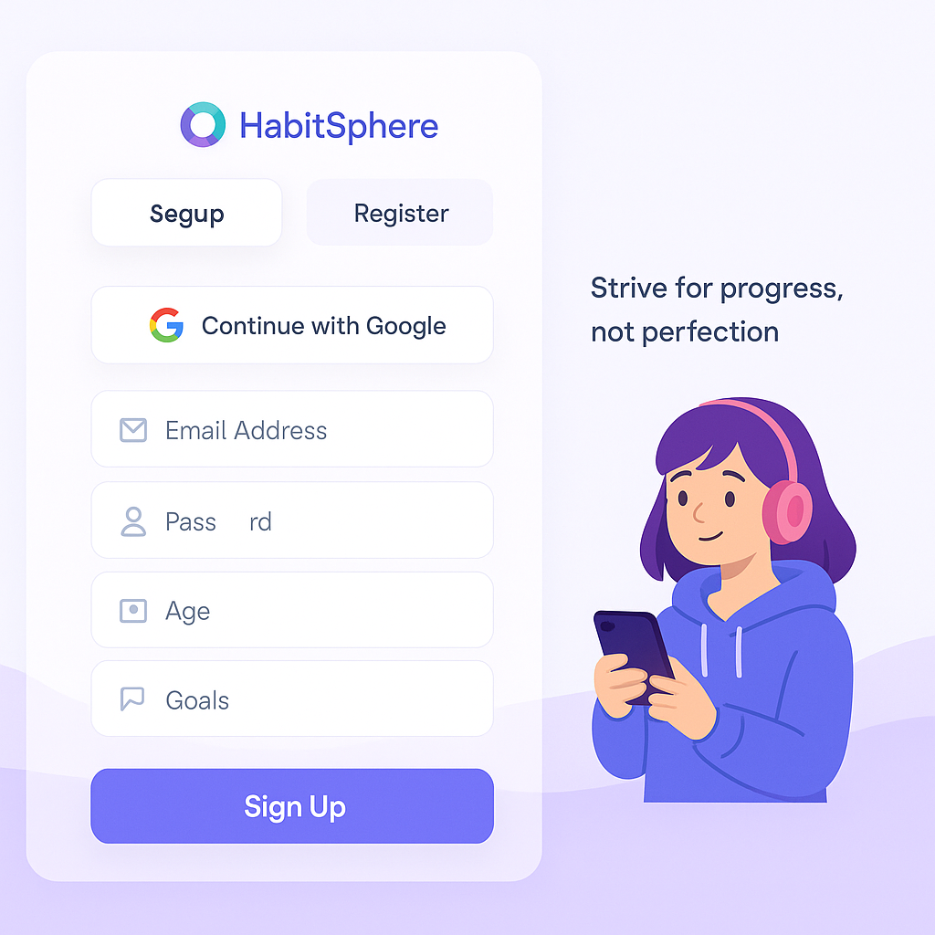

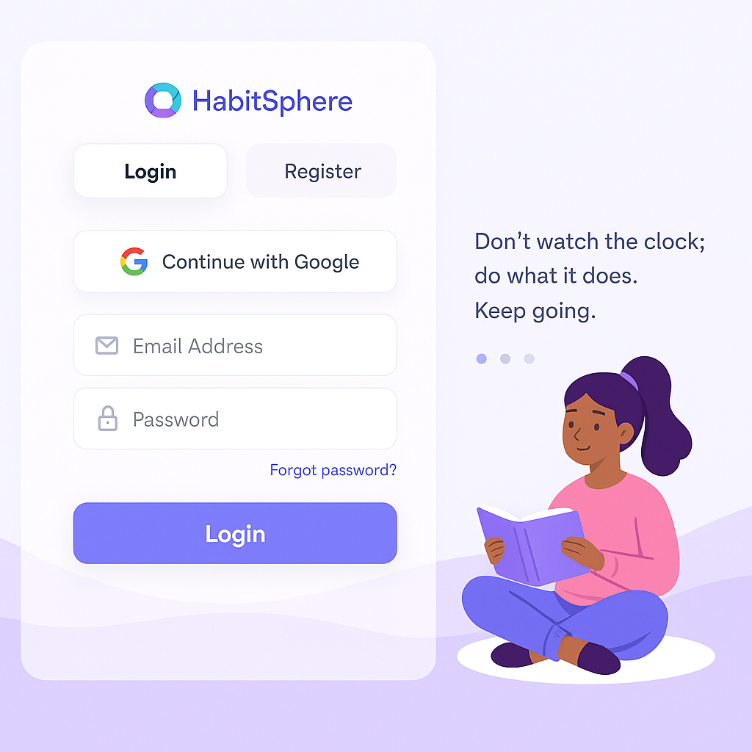

**🧑‍💻 2. Profile Setup Page**

**🧩 Components:**

* Stepper Form UI (Name → Age → Schedule → Goals)
* Sliders for “morning/evening productivity” preference
* Emoji-based mood selector
* Avatar Picker (with GenZ-styled illustrations)
* Save & Continue button with glowing animation

**📁 Files:**

* profile.html, profile.css

**🖼️ Image Inspiration:**

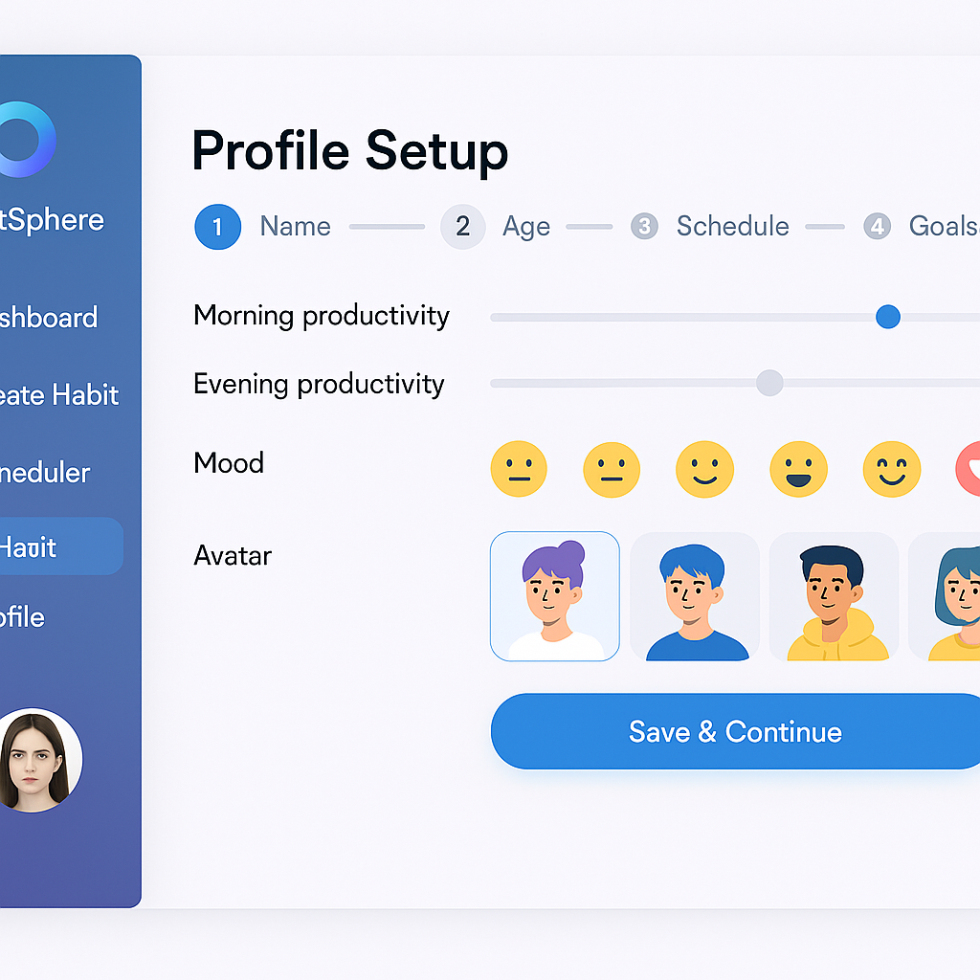

**🏠 3. Home Dashboard (Post-login)**

**🧩 Components:**

* Top section: Greeting (“Hey [Name], let’s crush it today 💪”)
* “Today’s Habits” in swipeable carousel cards
* Stats summary (completion rate, current streak)
* Weekly Chart (using Chart.js)
* AI Assistant Button (bottom right floating icon)

**📁 Files:**

* dashboard.html, dashboard.css
* habit_card.js for dynamic rendering

**🖼️ Image Inspiration:** 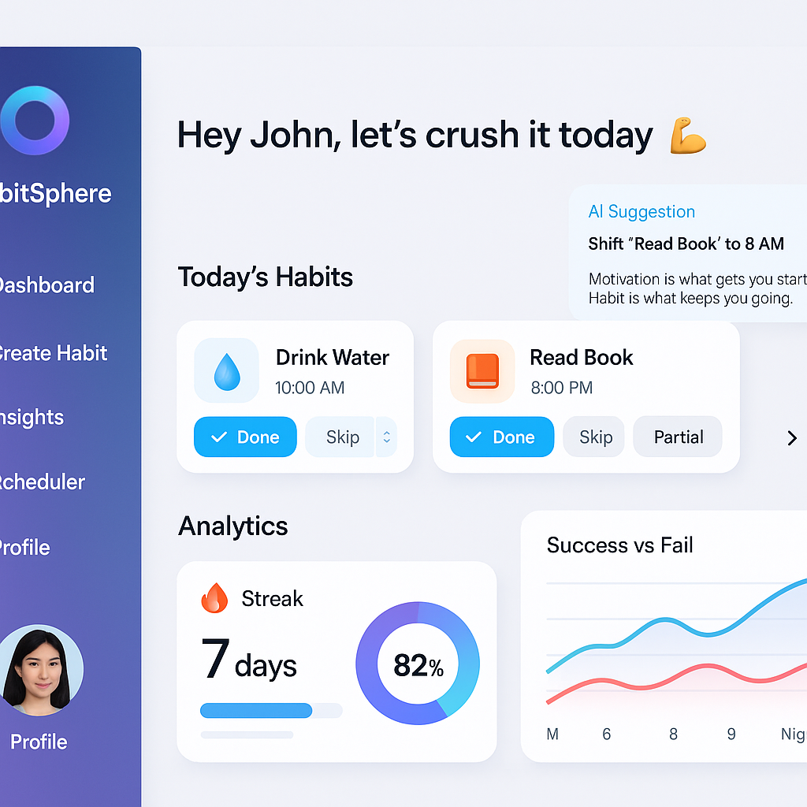

**📝 4. Create Habit Page**

**🧩 Components:**

* Habit name input with habit icon suggestion
* Time picker (slider clock style)
* Frequency selector (days of week with toggles)
* Goal Duration (calendar picker)
* Animated mascot that reacts to inputs

**📁 Files:**

* create_habit.html, create_habit.css

**🖼️ Image Inspiration:**

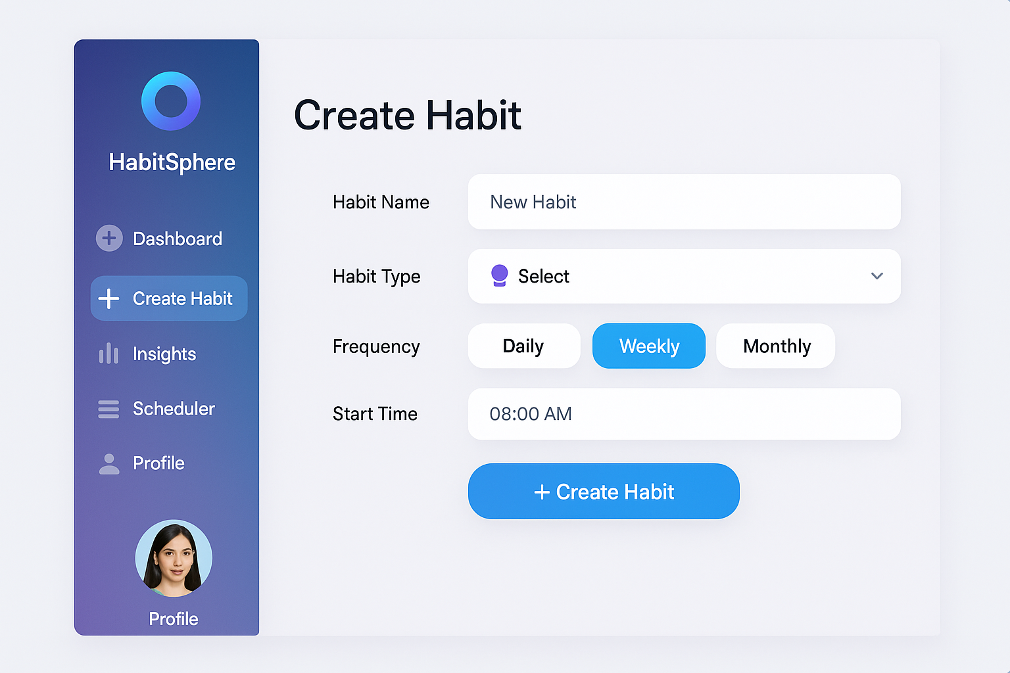

**💡 5. AI Habit Suggestion Page**

**🧩 Components:**

* Carousel of suggested habits (card swipe with reasons)
* Each card has “Why we suggest this” tooltip
* Accept Habit button → flows into Create Habit
* “Not interested” gives alternate suggestions

**📁 Files:**

* habit_recommendations.html

**🖼️ Image Inspiration:**

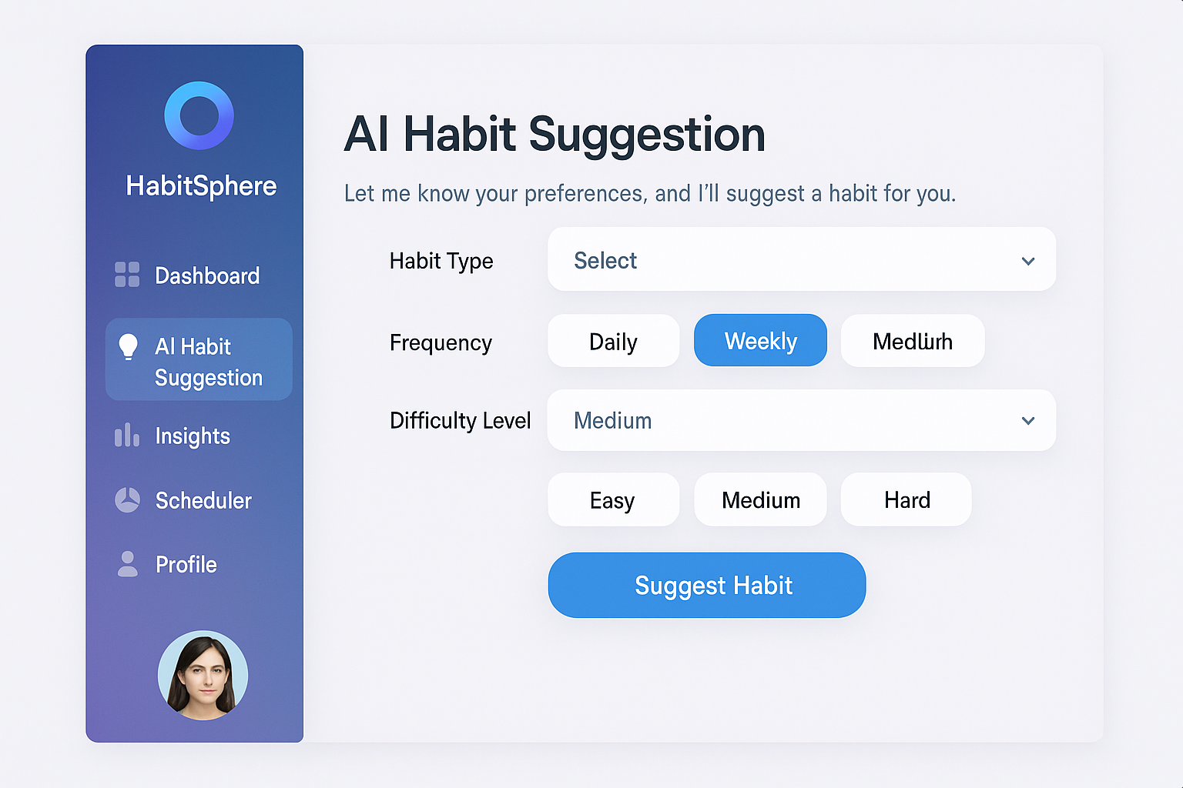

**📅 6. Smart Scheduler Page**

**🧩 Components:**

* Smart calendar view
* AI-selected optimal time highlight
* Drag to reschedule + edit
* “Boost productivity” tips section

**🖼️ Image Inspiration:**

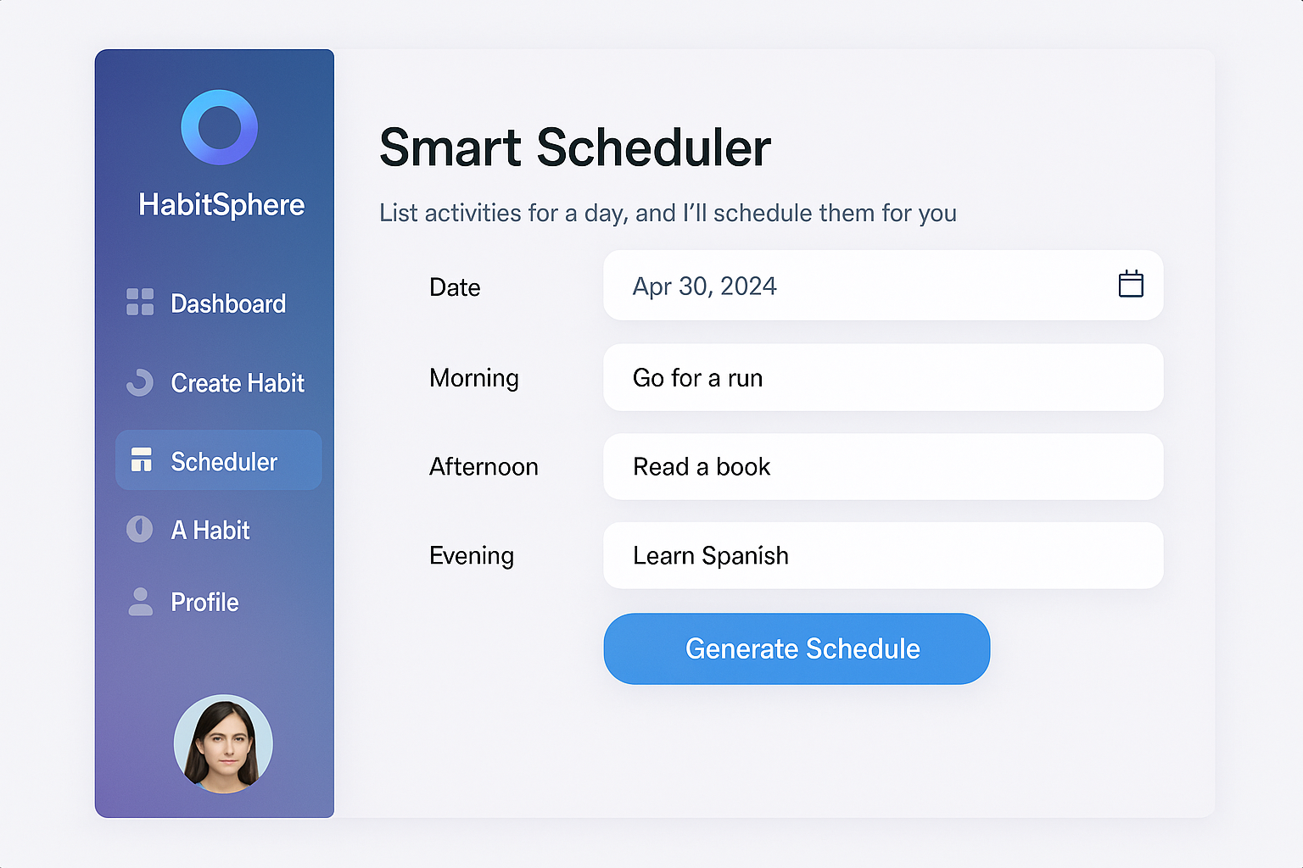

**🔮 7. Habit Success Predictor Page**

**🧩 Components:**

* Prediction result: “Your habit survival probability: 82% 🌟”
* Causes & Remedies shown in cards
* Motivational micro-goals & habit quote generator
* Lottie animation for encouragement (fire streak, celebration)

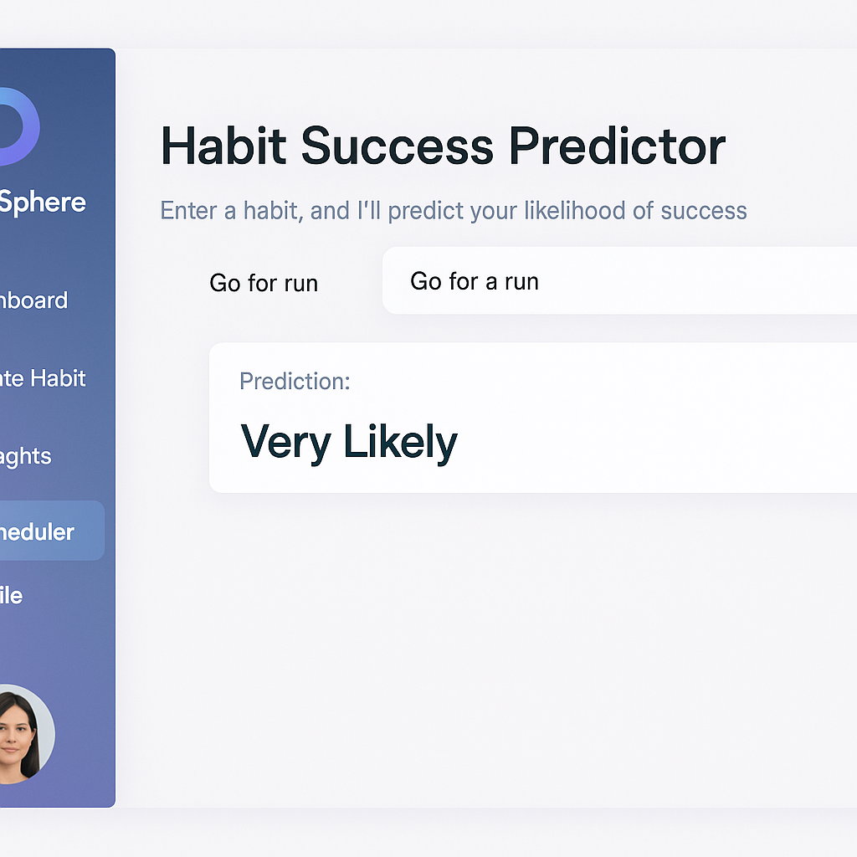

**📊 8. Analytics & Progress Dashboard**

**🧩 Components:**

* Habit streaks (flame icon, gamified)
* Completion % donut
* Daily/Weekly progress bar
* AI insight feed: “Why your reading habit fails on Friday”

**🖼️ Image Inspiration:**

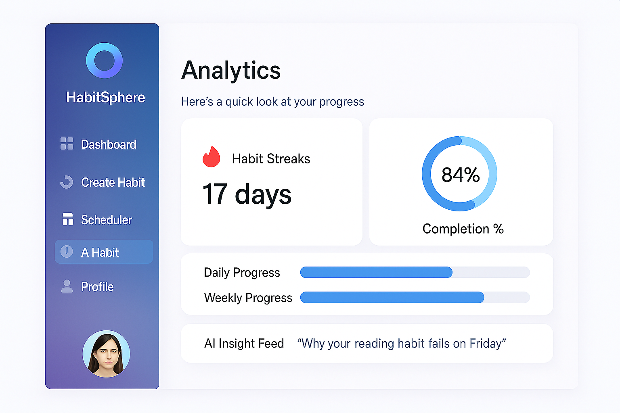

**🚫 9. Distraction & Blocker Monitor (Optional)**

**🧩 Components:**

* Timeline with peak distraction heatmap
* Suggestions: "Pause Instagram 3-4pm" 📵
* Break suggestions with breathing exercises
* Browser extension integration placeholder

